**GETTING STARTED WITH JAVA SPRING FRAMEWORK**

**Why Spring Framework?**

1. You can build a **variety of applications using Java Spring and Spring Boot**:
   * Web
   * REST API
   * Full Stack
   * Microservices
2. Irrespective of the app you are building:
   1. Spring framework provides all the **core features**.
      1. Understanding Spring **helps you learn Spring Boot** easily.
      2. Helps in **debugging** problems quickly.

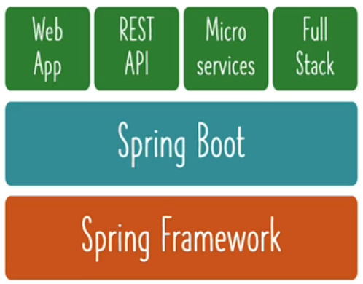

Let’s start working with **Spring Framework**

**Design Approach**:

**Design Game Runner to run games (Mario, SuperContra, Pacman etc) in an iterative approach:**

1. **Iteration 1**: Tightly Coupled Java Code
   * GameRunner class
   * Game classes: Mario, SuperContra, Pacman etc
2. **Iteration 2**: Loose Coupling - Interfaces
   * GameRunner class
   * GamingConsole interface
     + Game classes: Mario, SuperContra, Pacman etc
3. **Iteration 3**: Loose Coupling - Spring Level 1
   * Spring Beans
   * Spring framework will manage objects and wiring.
4. **Iteration 4**: Loose Coupling - Spring Level 2
   * Spring Annotations
   * Spring framework will create, manage and auto-wire objects.

